Transforming Gender Equality and Women Empowerment in Value Chain Development:
A case of Business Literacy in High Value Agriculture Project, Nepal
Tribhuban Paudel
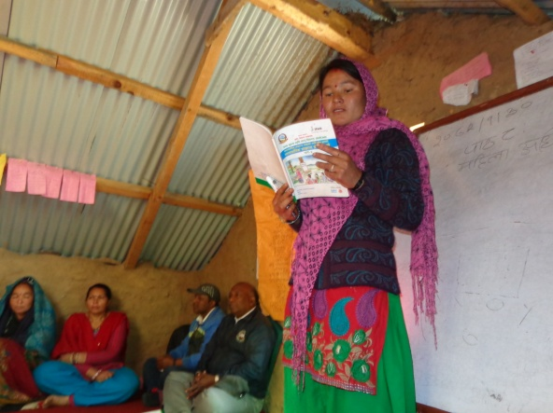
The Context:
It is a hard fact that economically active rural women, who contributes more than 87 percent of their time in agriculture but there are a number of evidences that proves they are neglected actors in value chains including every dimensions of socio-economic life. Mostly, the poor women left behind at the village after out migration of their male counter parts for employment, are primarily depended on agriculture, but remain exclusively subsistence, mainly due to low level of exposure on improved technology, limited access to improved production technical knowledge, access to production asset and inputs, inadequate knowledge on market opportunities and potentiality of income. There exists deep rooted inequalities, widespread gender gaps, governance issues, and individual skills to earn, save and mobilize the resources for wellbeing of family members. Therefore, there is a need of intensive intervention that includes a systematic analysis, learning and opportunity to translate these learning into actions.
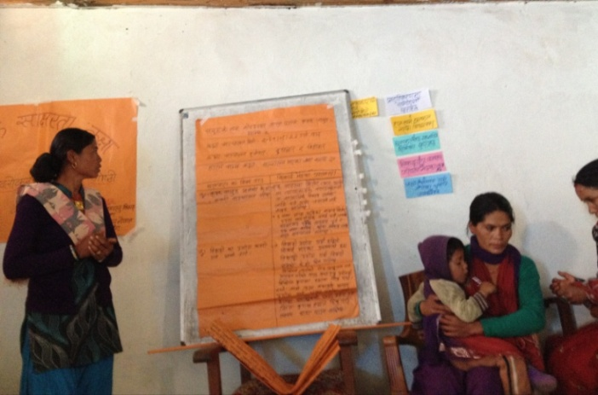
Besides, facilitating in different aspects of value chain development, capacity building mainly on three aspects a) increase production b) strengthen institutions, and c) marketing with the purpose to promote social and gender justice and empower women in value chain development is crucial need.
Business Literacy Classes:
A comprehensive package, as Business Literacy Class (BLC), can be an approach to transform the learning and actions and complement interventions bring anticipated results in value chains through promoting gender equality and empowering women.
High Value Agriculture Project in Hill and Mountain Areas (HVAP) implemented in Western Nepal is implementing BLCs in Produce Groups (farmer groups and cooperatives) working with the Project.
Outputs:
In 2014, a total of 29 BLC classes were carried out (a separate brief–Business Literacy Class: an approach to transform gender and social inclusion in value chain development- can access in www.hvap.gov.np). This year (2015) 48 classes are running in 7 project districts in 48 producer groups viz 20 Cooperatives and 28 Groups. These 48 classes cover 6 value chains, of the total, Goat covers 33 percent, Off Season Vegetable 23 percent, Apple 19 percent and remaining 3 spice value chains- Ginger, Turmeric and Timur cover 25 percent. BLCs run for 6 months, 2 days in a week, 3 hours a day. Participants themselves decide the day and time along with facilitator as their convenience that's why classes are running at morning and afternoons. In order to make the class effective, there is flexibility that participants themselves can decide and halt classes during their busy agricultural schedules and run during free times. All these 48 classes were started from 1st and 2nd week of January 2015 and are expected to complete by June 2015.

In total 77 classes, a number of 1987 producer farmers, comprising 18 % Dalits and 14% Janajatis, are actively participating in classes, learning and bringing meaningful changes in understanding, production and earning, promoting gender justice and making agriculture a profitable business. Women, who had hardly any opportunity in formal education, are learning reading, writing and calculating their daily transactions using calculator. Of the total participants 96.83 percent are women (Dalits-96.34%, Janajati-99.64% and other Caste 96.39%) who are directly involved in production, sales of the value chain commodities and earning more money at their own.
Before starting these classes, 77 facilitators (73 women and 4 men) were selected from respective community and trained on the objectives, outputs, content of the discussion materials/curriculum and process along with methodology of facilitation for a week period during 2nd and 3rd week of December 2014. These facilitators are directly involved in overall facilitation of BLCs.
After 3 months period, Review and Refresher Workshops in all the districts were conducted with the objectives a) to understand the level of learning and actions taken to transfer the learning into actions and b) to encourage participant, improve facilitators' skills and improve the tools and methodology. During training of trainers, only facilitators and Social Mobilizers were participants but in review, chairperson, one participant and facilitators were attended in the workshop.
What are the factors that foster changes?
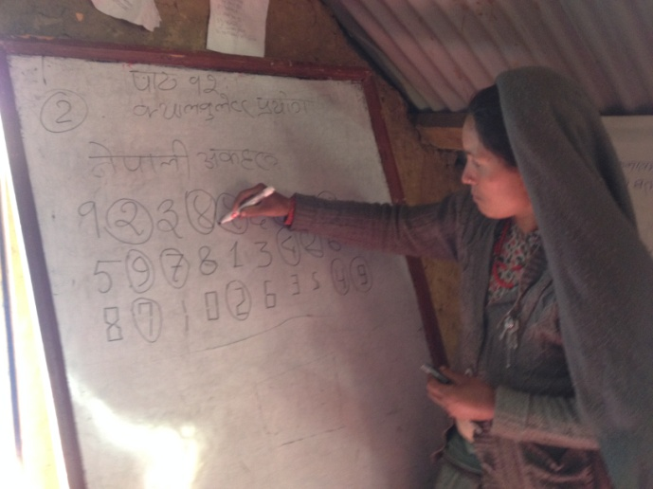
Selection of Facilitator from the Same Community: Facilitators are selected from the same community having +12 grades passed, mature and involved in agricultural activities. Priority is given to women candidates. Comprehensive Training of Trainers for Facilitators - a seven days intensive training on the subject matter to be facilitated, approach, methodology, tools and process and send back to the community to run the classes. Empathy of the facilitators with participants has greatly contributed to make it effective.
Detail and systematic resource materials: A comprehensive package of three modules a) production and management, b) strengthening instructional aspect, c) market and marketing, has covered most of the related topics that facilitate farmers to upgrade their knowledge and change their farming and marketing practices with promoting justice is developed, printed and distributed to all the participants. Although there are some pictures with reading texts, it has been felt to increase the number of pictures/illustrations and reduce the volume of text. Making flipcharts with illustrations is under process and will be ready for next year classes. Related topics and materials were added with feedbacks from participants and facilitators like use of pesticides and precautionary measures, manure and process of making organic manure, and many other topics.
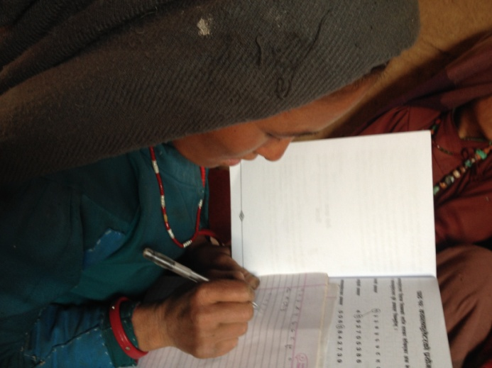
Approach of learning and translating into actions: Basically, facilitators interacts and facilitate participants to upgrade their knowledge on the topics decided by participants from the resource books and some time they talk if any important new topics emerges. In 3 hours classes, participants discuss on the topic, identify best learning and the learning that can be transferred into action. Then, review the actions of change in each class and encourage each other for change in their actions. Some time participants plan such actions that can be accomplished jointly like preparing fodder nursery, vegetable nursery for off-seasons production and transplant seedlings individually in their farm land. About 30 minute each day, they practices numeracy and use of calculator for simple mathematics and calculations of interest and percentage.
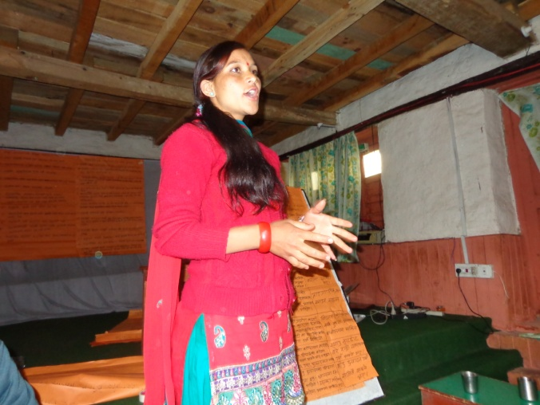
Incentives: A small token of incentive such as cost for refreshment and booklets, stationary were made available for participants, and calculators and other training materials for class which supports to make the participants regular. In most of the cases, beside snacks, women bring snacks from their home and the money allocated for refreshment has been used as seed money to initiate new agricultural practices for example, purchase vegetable seeds.
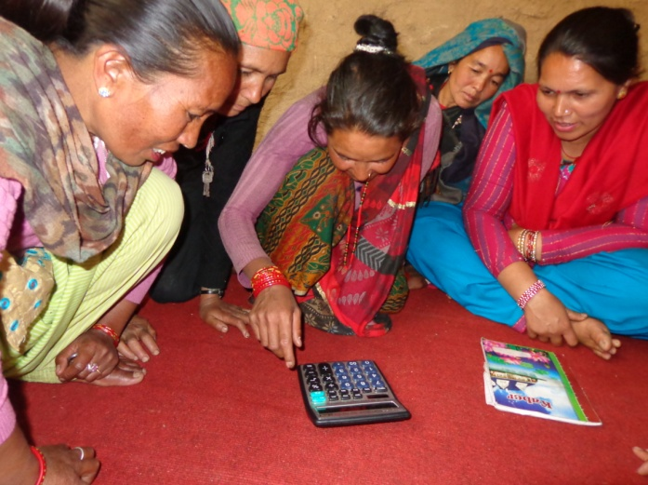
Regular follow-up, review and refresher: Follow-up from social mobilizers, and staff of the Project, coaching facilitators and encourage participants have greatly contributed to improve the effectiveness. Conducting review and refresher workshops in participation of facilitator, chairperson of group/cooperative and refresher on methodology, approach, facilitation skills has great impacts to improve the effectiveness of classes and enhance the capacity of facilitators.
In conclusion, it can be said that systematic learning process, intensive coaching and facilitate learning and translating learning into actions can change the behavior of participants, production and marketing practices and ultimately contribute in value chain development.

Mr. Tribhuban Paudel is working as Gender, Social Inclusion and Group Development Expert in HVAP.

